Steps to Install PostGreSQL 15.3 and Launch pgAdmin

**Step1: Go to** [**https://www.postgresql.org/download**](https://www.postgresql.org/download) **(This document is based on Windows 10 Pro , 64 bit)**

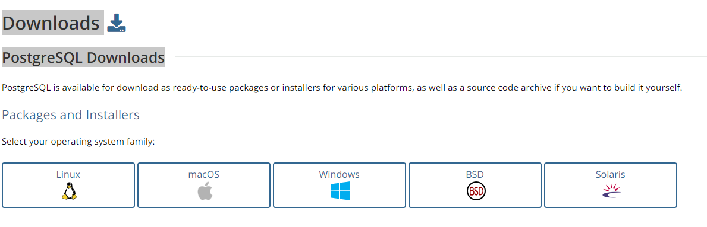

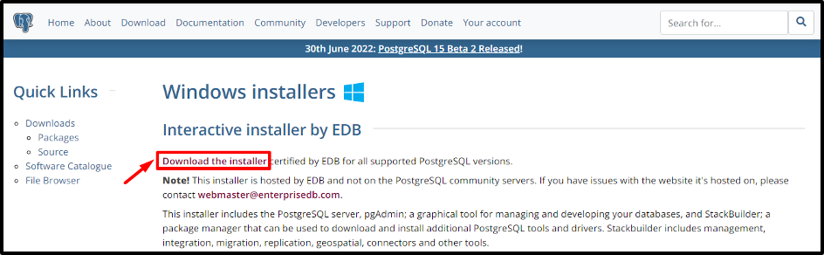

**Step2: Select your OS**

Select the operating system on which you want to download the **PostgreSQL**. In our case, its Windows operating system:

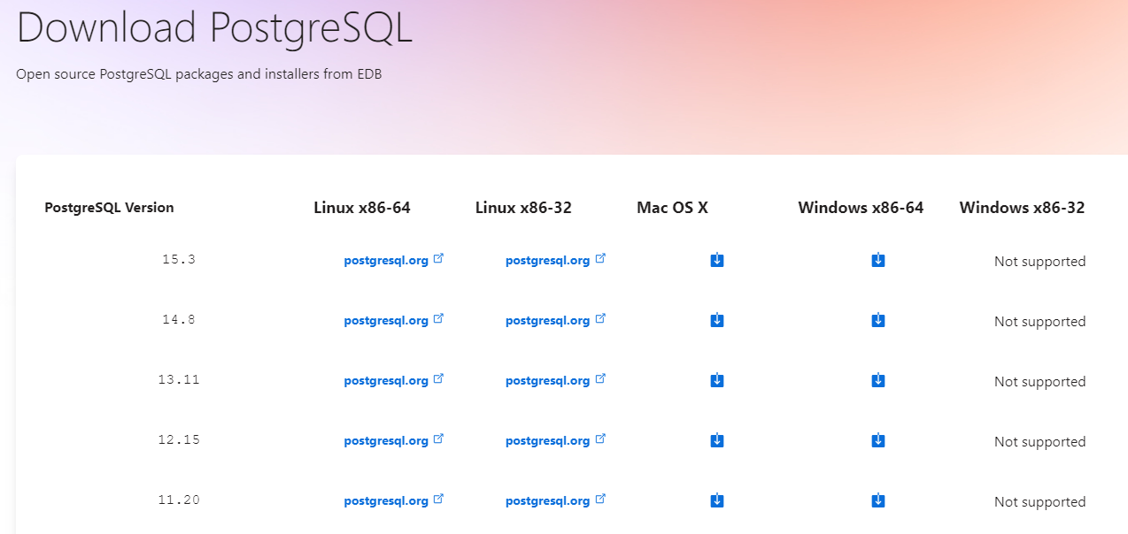

Clicking on the download button will start the downloading process:

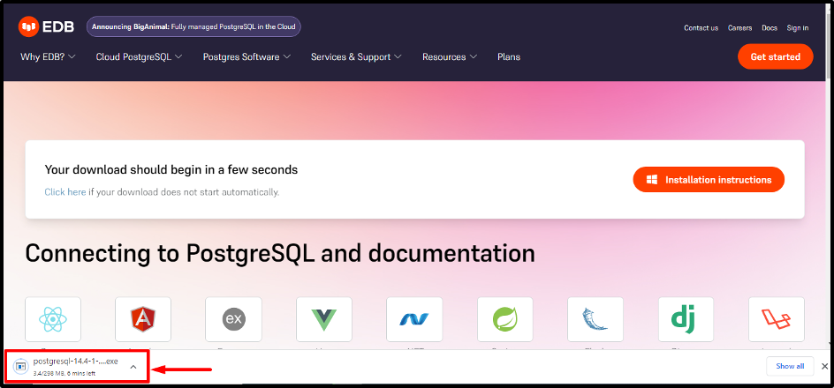

**Step3.**  Once the downloading is completed, open the respective **“.exe”** file

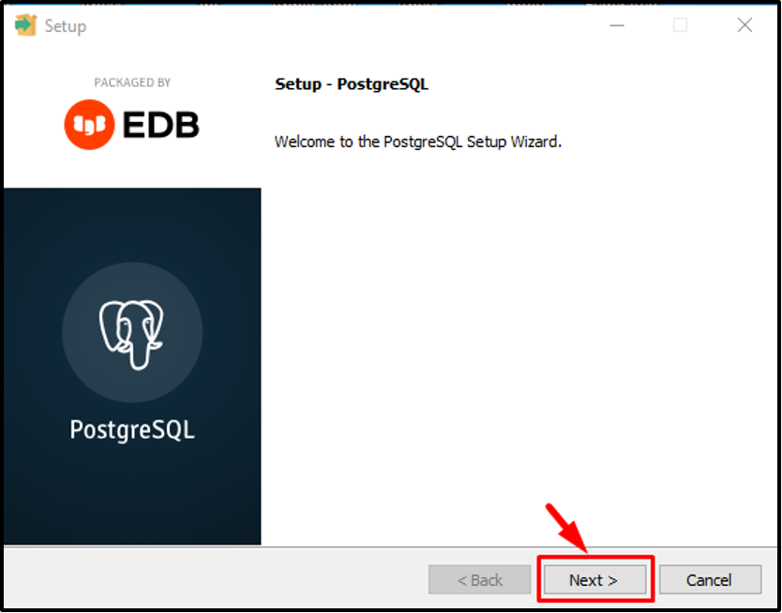

**Step 4**. Specify or browse the directory where you want to install the **PostgreSQL**:

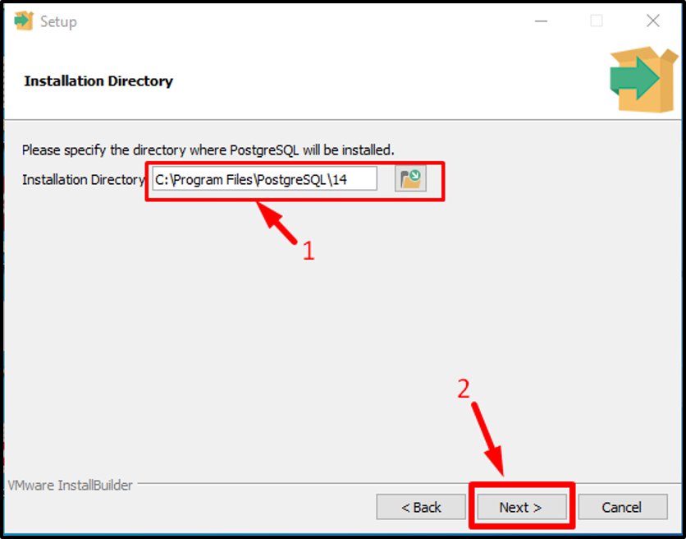

**Step 5**. **Select Components and Click Next**

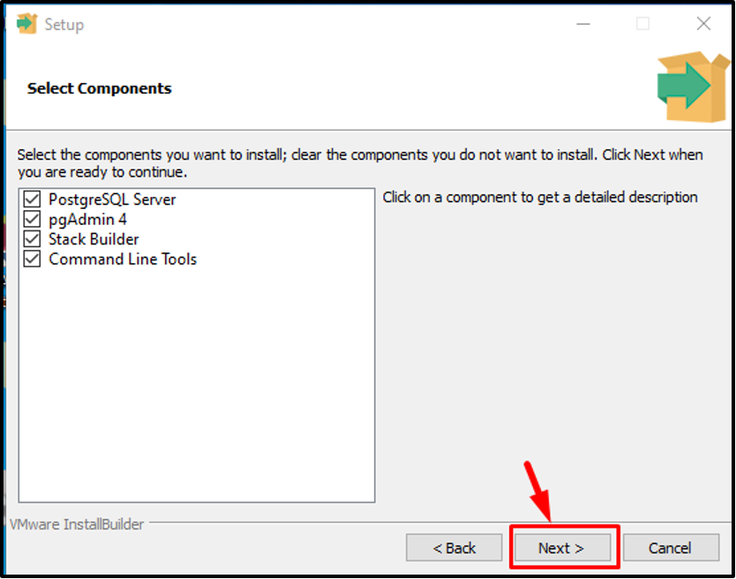

**Step 6**. Select a data directory to store your data and click on the **“Next”** button:

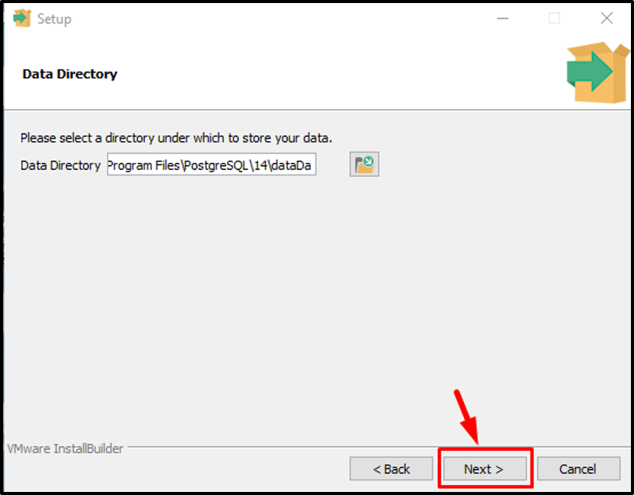

**Step 7**. Set a password (must remember it for later use) for the Postgres superuser and click on the **“Next”** button

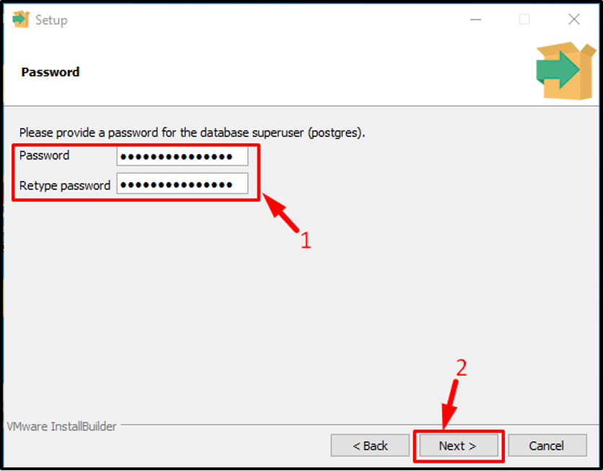

**Step 8**. Whether set the port number or go with the default port number **“5432”** to connect to a database:

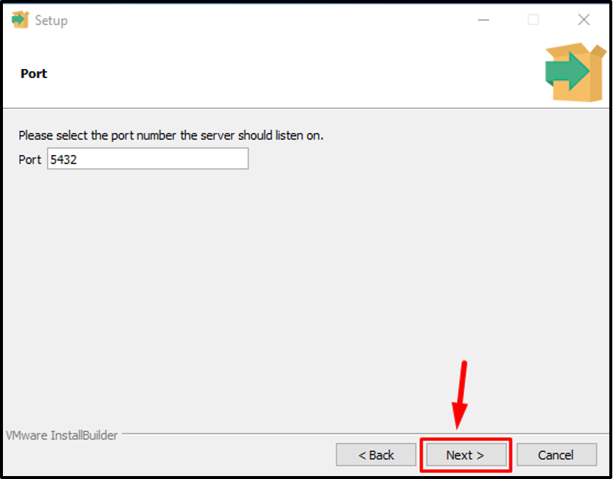

**Step 9.**. The next window will give you choice to select locale; leave them as it is, and click on the **“Next”** button:

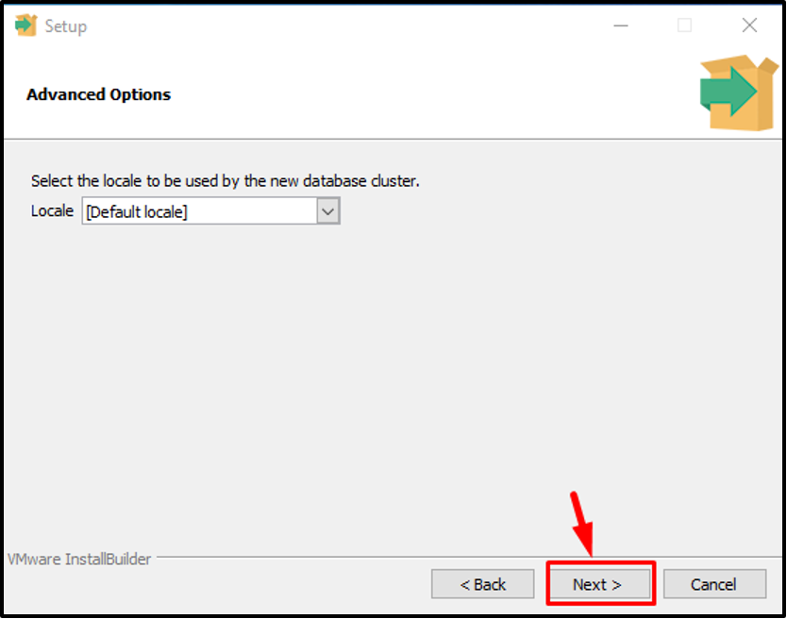

**Step 10**. **Verify Pre-installation Summary**

The pre-installation summary will tell you which settings will be used for the installation:

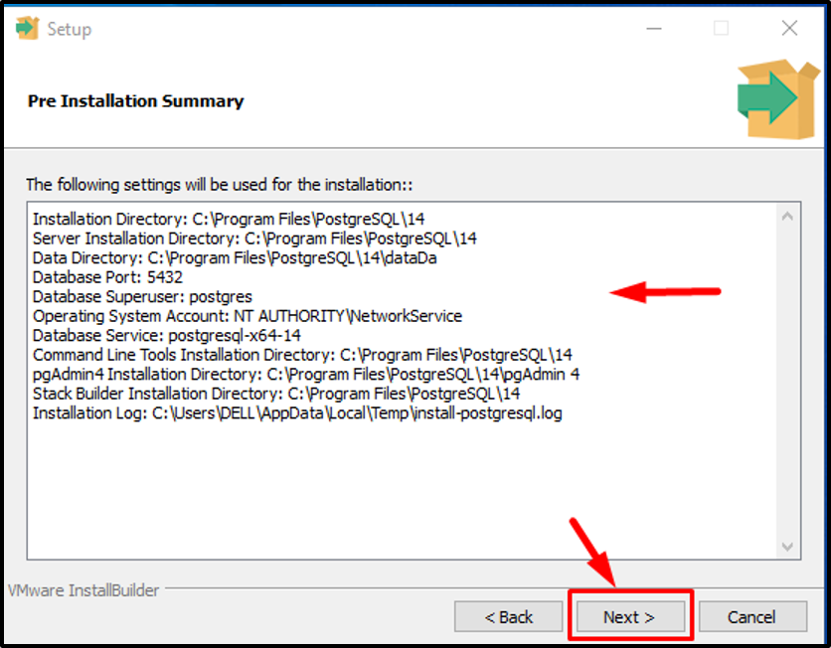

**Step 11**. **Begin PostgreSQL Installation**

The setup is ready to install **Postgres** on your windows operating system:

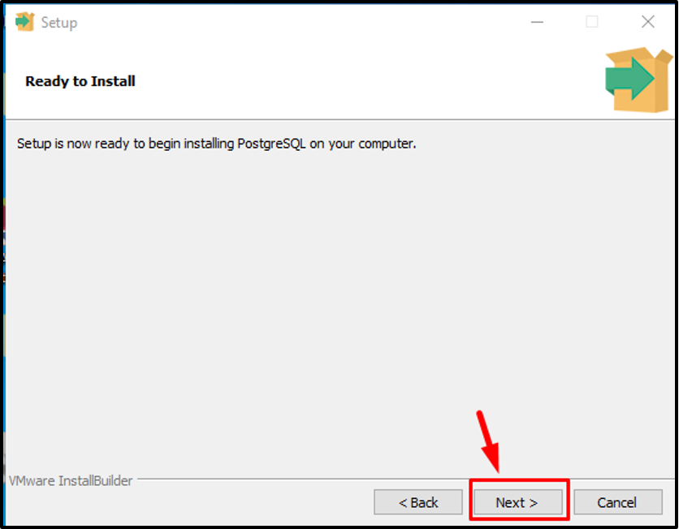

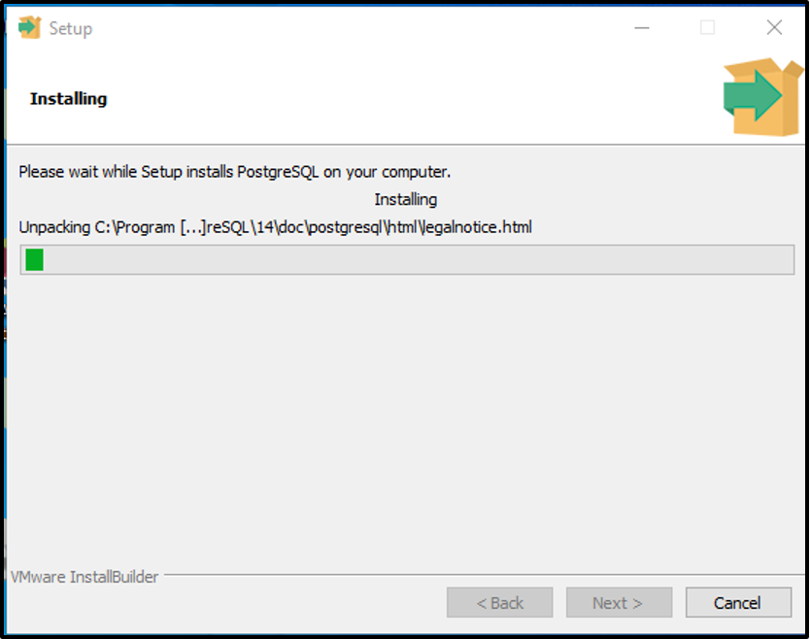

The whole process will take a few minutes to complete:

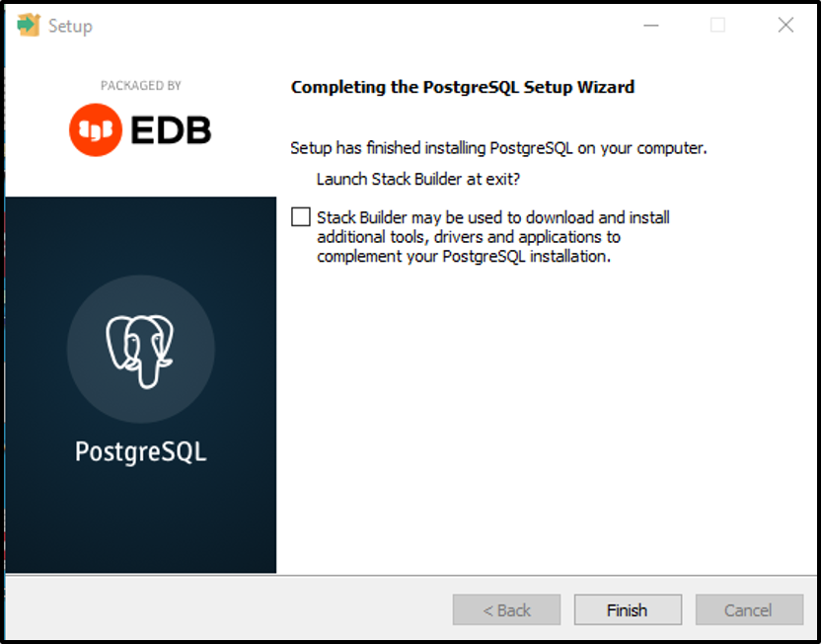

Once the **PostgreSQL** setup wizard is completed, click on the “**Finish**” button to close the installation windows.

Steps to launch PostgreSQL on Windows 10

**Step 1: Open pgAdmin**

Click the windows button and find the **“postgreSQL 14”**. Once you find it click on it and select the **“pgAdmin 4**

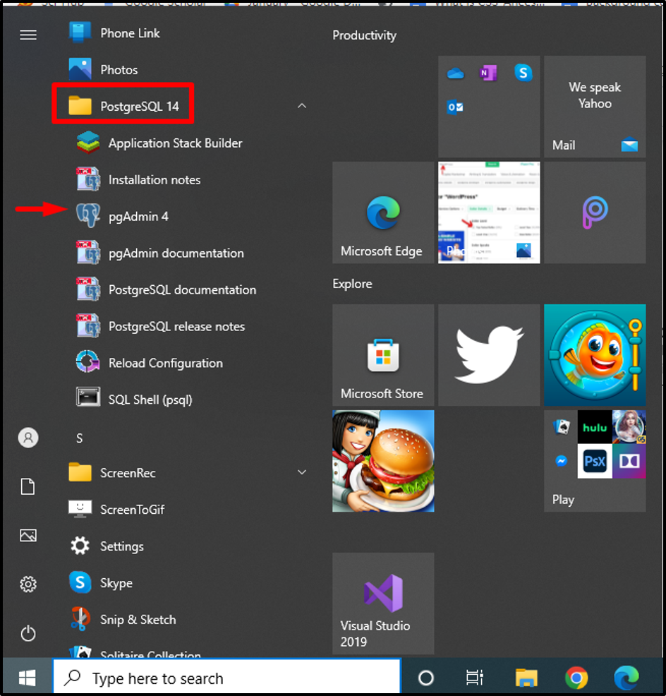

**Step 2: Enter Password**

Clicking on the **“pgAdmin 4”** will ask you to enter the password:

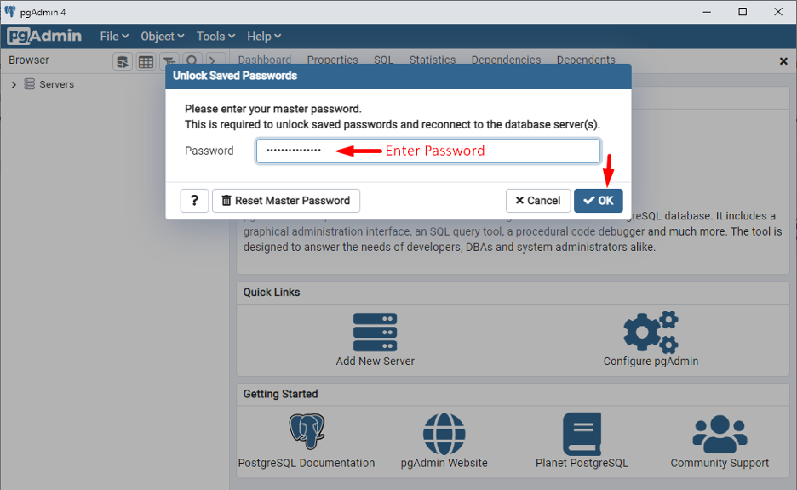

**Step 3: Select PostgreSQL 14**

In the left pane, click on the **“Servers”** and then **“PostgreSQL 14”**. Consequently, the following dashboard will appear:

